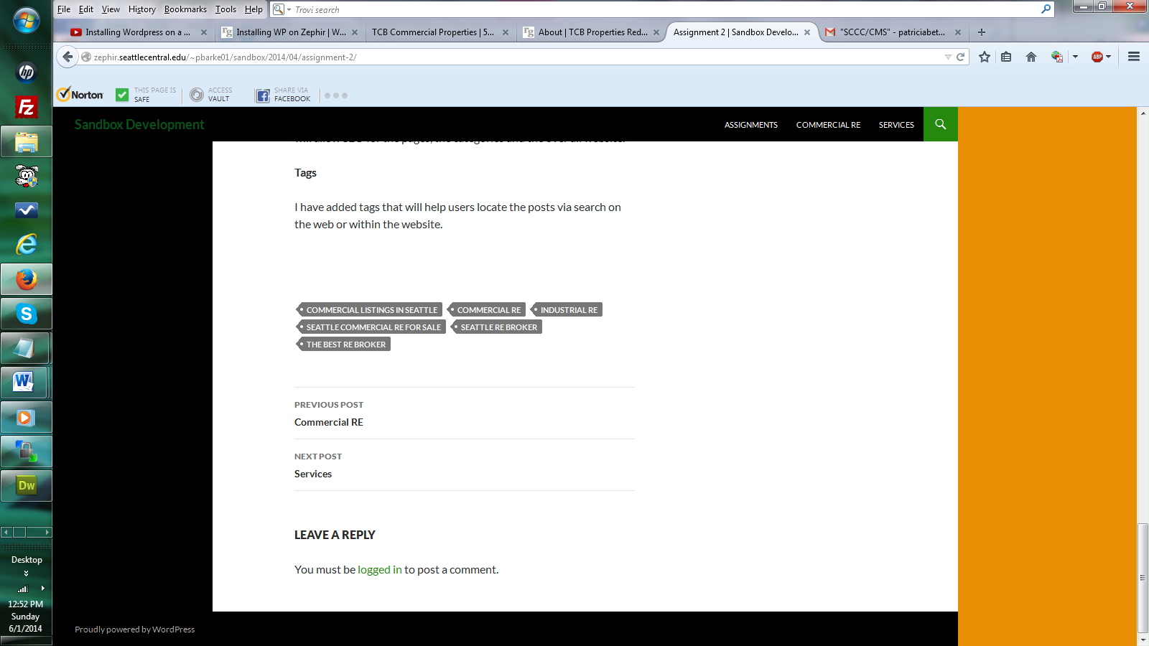

PBBWebDesign

$imon4Me!